**Boston University**

**Electrical & Computer Engineering**

**ClearSol**

**Final Prototype Testing Plan**

By Team 29

ClearSol

Team Members

Fabio Amado [famado@bu.edu](mailto:famado@bu.edu)

Zachary Capone [zcapone@bu.edu](mailto:zcapone@bu.edu)

Julian Leguizamon [julianle@bu.edu](mailto:julianle@bu.edu)

Ryan Rosenberger [rjrose@bu.edu](mailto:rjrose@bu.edu)

Anthony Saab [saabanth@bu.edu](mailto:saabanth@bu.edu)

**Required Material:**

Hardware:

* Solar Panel Assembly & High Power LED Light
* 6V DC Power Supply (AC adapter)
* 18V DC Power Supply (Bench power supply)
* Monitoring Control Circuit
  + Raspberry Pi
  + 4 INA260 Power Sensors
  + Relay HAT
* Display/UI
  + Switches/Button Panel
  + 7 Segment LCD Display
* Assembled power circuit
  + Buck Converter
  + Supercapacitor Charge Controller
  + 4 400F supercapacitors
  + Primary boost converter
  + Secondary boost converter
  + Load resistor bank (EDS simulation)

Software:

* Python:
  + Gets data from INA260 Power Sensors
  + Initializes LCD Display and prints voltage and current data
  + Reads from the GPIO pins to determine the position of switch for the EDS
  + Activates the relay to turn on and off the simulated EDS load

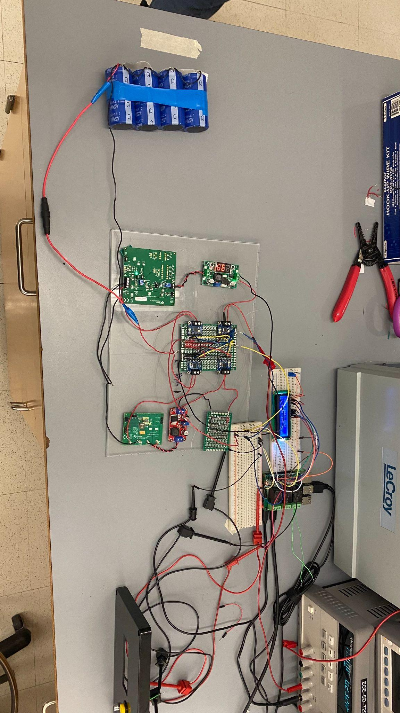

***Figure 1: Our wired up system ready for testing***

**Set-Up:**

The goal of this test is twofold: demonstrating the functionality of the power system and the functionality of the monitoring/control system. We aim to showcase these systems simultaneously, as our supercapacitors are charged and discharged.

First, we will demonstrate how our supercapacitor storage bank can be charged using a connected solar panel. The monitoring system will display both the solar panel voltage and output current, and the supercapacitor voltage and input current.

Second, we will demonstrate how the energy stored in our supercapacitor bank can be converted to supply an EDS-like load. The monitoring/control system will activate the load side of the power circuit when a user flips a switch. The monitoring system can then show the supercapacitor voltage and discharge current, and the load voltage and output current to the load.

The essence of our prototype testing is to utilize the circuit we currently have assembled as well as demonstrate activation of the circuit through both power coming in from the solar panel (as demonstrated with our high wattage LED lamp) as well as with a direct supply of power fed into the circuit through our power supply.

**Pre-Testing Procedure:**

1. Ensure that the physical circuit is laid out neatly on the table so that all connections and components are clearly visible.
2. Connect an 18V DC power supply to the input of the power circuit.
3. Precharge the supercapacitor bank to 2.5V.
4. Place the solar panel assembly beneath the LED lamp.
5. Disconnect DC power supply from power circuit input, and connect solar panel to power circuit input.
6. Boot python in the Raspberry Pi for switch demonstration.
7. By repeatedly long pressing the button on the control panel, cycle the measurement display until the solar panel measurements are displayed.

**Testing Procedure:**

1. Activate the LED lamp and adjust it to its brightest setting.
2. Observe the power readings associated with the solar panel. Verify that the panel is operating at a reasonable output voltage, and that it is supplying current to the power circuit.
3. Cycle the measurement display until the supercapacitor input measurements are displayed.
4. Observe the power readings associated with the supercapacitor input. Verify that the supercapacitors are receiving current from the charger, and that the supercapacitor voltage is increasing.
5. Turn off the LED light.
6. Cycle the measurement display until the solar panel measurements are displayed.
7. Verify that the solar panel is not supplying significant current to the power circuit.
8. Cycle the measurement display until the supercapacitor output measurements are displayed.
9. Observe the supercapacitor voltage, and verify that the supercapacitors are not discharging.
10. Turn on the EDS load by flipping the switch.
11. Observe the supercapacitor discharge current, and verify that the supercapacitors are now discharging.
12. Cycle the measurement display until the load measurements are displayed.
13. Observe the load measurements. Verify that the load is being supplied with a voltage of 12V, and that roughly 1.3W are being consumed by the load.

**Measuring Criteria**

The criteria for successful running and output is as follows:

1. The monitoring system is able to display voltage and current measured by all four power sensors.
2. The supercapacitors charge when connected to the illuminated solar panel.
3. The supercapacitors discharge and supply adequate power to the load when triggered by a user.

**Score Sheet (Part 1)**

| Expected Behavior | Observed? |
| --- | --- |
| Supercapacitors charge when connected to illuminated solar panel |  |
| Supercapacitors discharge and supply power to load when load is turned on by user |  |
| Measurement system displays power measurements for all four sensors |  |

**Conclusion**

By successfully accomplishing all of our goals in our testing plan we will be able to demonstrate a fully functioning system that accomplishes the entire scope of our project. We will be able to demonstrate supercapacitor charging when hooked up to our solar panel, supercapacitor discharge to supply our EDS load and a monitoring and control system to regulate and monitor different measurements around our system.